CHAPTER 1 INTRODUCTION 1
Overview 2
Objectives 2
Scope 2
Definitions 2
CHAPTER 3 BACKGROUND RESEARCH 3
Cluster Computing 3
Economic Models 9
Cluster Scheduling 10
Cluster Management Software 11
CHAPTER 5 SCHEDULING AND RESOURCE MANAGEMENT with 17
LIBRA 17
5.1 Scheduling and Resource Management with Libra 17
5.1.1 Scheduling Algorithm 17
CHAPTER 6 21
IMPLEMENTATION 21
6.1 Scheduling Environment: PBS 22
6.1.1 PBS components 22
6.1.2 Scheduler-Server Interaction 23
6.2 Libra with PBS 24
CHAPTER 7 26
USER INTERFACE 26
7.1 User Characteristics 27
7.2 Libra with PBS-Web 27
Figure 5: The Script Submission Results Page for the PBS-Libra Engine 31
Figure 7: Viewing the Job Output and Error Files through PBS-Web 33

CHAPTER 1 INTRODUCTION

Overview

Objectives

Scope

Definitions

CHAPTER 3 BACKGROUND RESEARCH

Cluster Computing

(The information contained in this section is adapted from ‘Cluster Computing at a Glance: High Performance Cluster Computing Volume 1’, Rajkumar Buyya.)

Before understanding cluster computing, it is imperative to understand the nature of parallel computing; cluster computing may be consider as a type of parallel computing.

Parallel processing, which in essence means linking together two or more computers to jointly solve some computational problem, is one of the best ways to overcome the speed bottleneck of a single processor. In addition, the price performance ratio of a small cluster-based parallel computer is small compared to that of a specialized supercomputer, and is hence much more cost-effective. The trend in parallel computing is to move away from specialized traditional supercomputing platforms, such as the Cray/SGI T3E, to cheaper, general purpose systems consisting of loosely coupled components built up from single or multiprocessor PCs or workstations.

The following list highlights some of the reasons Networks of Workstations (NOWs) are preferred over specialized parallel computers:

- Individual workstations are becoming increasingly powerful. Workstation performance has increased dramatically in the last few years and is doubling every 18 to 24 months. This is likely to continue for several years, with faster processors and more efficient multiprocessor machines coming into the market.
- The communications bandwidth between workstations is increasing and latency is decreasing as new networking technologies and protocols are implemented in LANs.
- Workstation clusters are easier to integrate into existing networks than specialized parallel computers.
- Low user utilization of personal workstations provides an opportunity to tap into otherwise unutilized computing resources.
- Clusters can be easily expanded: adding memory or additional processors can easily increase a node’s capability. Thus a NOW is much more scalable than a specialized supercomputer.

Of the various scalable parallel computer architectures available, our focus is on clusters. At a basic level a cluster is a collection of workstations or PCs that are interconnected via some network technology. For parallel computing purposes, a cluster will generally consist of high performance workstations or PCs interconnected by a high-speed network. A cluster works as an integrated collection of resources and can have a single system image spanning all its nodes.

The following are some prominent components of cluster computers:

- Multiple High Performance Computers: (PCs, Workstations, or SMPs)
- Operating Systems: (Layered or Micro-kernel based)
- High Performance Networks/Switches: (such as Gigabit Ethernet and Myrinet)
- Network Interface Cards: (NICs)
- Fast Communication Protocols and Services: (such as Active and Fast Messages)
- Cluster Middleware: (Single System Image (SSI) and System Availability Infrastructure)

If a collection of interconnected computers is designed to appear as a unified resource, we say it possesses a Single System Image (SSI). The SSI is supported by a middleware layer that resides between the operating system and user-level environment. The cluster nodes can either work collectively as an integrated computing resource or as individual computers. The cluster middleware is responsible for offering an illusion of a unified system image (single system image) and availability out of a collection on independent but interconnected computers.

The benefit of a Cluster Middleware/Single System Image is that the exact location of the execution of a process is entirely concealed from the user, as are the load balancing and process migration strategies employed by the Cluster Management System/ Scheduler.

Ideally, a Single System Image should offer its users the following services, which can serve as a benchmark for evaluating/deciding upon a Cluster Management System:

- Single Point of Entry: A user can connect to the cluster as a single system (like telnet beowulf.myinstitute.edu), instead of connecting to individual nodes as in the case of distributed systems (like telnet node1.beowulf.myinstitute.edu).
- Single File Hierarchy (SFH): On entering into the system, the user sees the file system as single hierarchy of files and directories under the same root directory. Examples: xFS and Solaris MC Proxy.
- Single Point of Management and Control: The entire cluster can be monitored or controlled from a single window using a single GUI tool, similar to an NT workstation managed by the Task Manager tool.
- Single Virtual Networking: This means that any node can access any network connection throughout the cluster domain even if the network is not physically connected to all nodes in the cluster.
- Single Memory Space: This offers the illusion of a very large, unified memory, actually comprising the memory of individual cluster nodes.
- Single Job Management System: A user can submit a job from any node using a transparent job submission mechanism. Jobs can be scheduled to run in batch, interactive or parallel modes. Example systems include LSF and CODINE.
- Single User Interface: The user should be able to use the cluster through a single GUI.
- Single I/O Space (SIOS): This allows any node to perform I/O operations on local or remote peripheral or disk devices.
- Single Process Space: Processes have a unique cluster-wide process id. A process on any node can create child processes on the same or different nodes (through a UNIX fork) or communicate with any other process on a remote node. The cluster should support globalized process management and allow the management and control of processes as if they were running on local machines.
- Checkpointing and Process Migration: Checkpointing mechanisms allow process state and intermediate computing results to be saved periodically. When a node fails, processes on the failed node can be restarted on another working node without loss of computation. Process migration allows for dynamic load balancing among the cluster nodes.

The choice of the Cluster Middleware defines the capabilities and limitations of the cluster, and is perhaps the most important decision in setting up a cluster, and in our case, also the most time consuming. The Cluster Middleware itself consists of many layers, and exists at different levels:

- Hardware (such as Digital (DEC) Memory Channel, hardware DSM, and SMP techniques)
- Operating System Kernel or Gluing Layer (such as Solaris MC and GLUnix)
- Applications and Subsystems
- Applications: (such as system management tools and electronic forms)
- Runtime Systems: (such as software DSM and parallel systems)
- Resource Management and Scheduling software: such as LSF (Load Sharing Facility) and PBS (Portable Batch Systems)

Scheduling is the area of focus of our project. The following is an overview of Resource Management and Scheduling (RMS).

Resource Management and Scheduling (RMS) is the act of distributing applications among computers to maximize their throughput. It also enables efficient utilization of the resources available. The software that performs the RMS consists of two components: a resource manager and a resource scheduler. The resource manager component is concerned with locating and allocating computational resources, authentication, process creation and migration. The resource scheduler component is concerned with tasks such as queuing applications, as well as resource location and assignment. RMS is responsible for load balancing, utilizing spare CPU cycles, fault tolerance and providing increased user application throughput. Applications can be run either in interactive or batch mode. In batch mode, an application is a job submitted to the RMS system to be processed. To submit a batch job, a user will need to provide job details to the system via the RMS client. These details may include information such as location of the executable and input data sets, where standard output is to be placed, system type, maximum length of run and whether the job needs sequential or parallel resources. Once a job has been submitted to the RMS environment, it uses the job details to place, schedule, and run the job appropriately. The focus of our project is to implement a scheduler that aims to maximize user satisfaction. Thus the job details submitted by the user will include job prioritization criteria: the allocated budget and the deadline required by the user, enabling the scheduler to maximize CPU utilization while remaining within the constraints imposed by the need to optimize user Quality of Service (QOS).

The services provided by an RMS environment include:

- Process Migration: A process can be suspended, moved or restarted on another computer within the RMS environment. Generally, process migration occurs when a computational resource becomes overloaded and there exist other free resources that can be utilized by migrating processes to them.
- Checkpointing: This is where a snapshot of an executing program's state is saved and can be used to restart the program from the same point at a later time if necessary. Checkpointing is generally regarded as a means of providing reliability. When some part of an RMS environment fails, the programs executing on it can be restarted from an intermediate point in their execution, rather than being restarted from the beginning.
- Scavenging Idle Cycles: Most workstations are idle between 70-90% of the time. RMS systems can be set up to utilize idle CPU cycles. For example, jobs can be submitted to workstations during low activity periods. This way, interactive users are not impacted by external jobs and idle CPU cycles can be taken advantage of.
- Fault Tolerance: By monitoring its jobs and resources, a RMS system can provide various levels of fault tolerance: job completion is ensured by eliminating a Single Point of Failure (SPOF), and ensuring restarting of a process on another node incase the host node fails.
- Minimization of Impact on Users: Running a job on public workstations can have a great impact on the usability of the workstations by interactive users. Some RMS systems attempt to minimize the impact of a running job on interactive users by either reducing a job's local scheduling priority or suspending the job. Suspended jobs can be restarted later or migrated to other resources in the systems.
- Load Balancing: To allow efficient resource usage, jobs are distributed among the nodes in the cluster. Process migration can also be part of the load balancing strategy, since it may be beneficial to move processes from overloaded systems to lightly loaded ones.
- Multiple Application Queues: Job queues can be set up to help manage the resources in a cluster. Each queue can be configured with certain attributes. For example, certain users prioritize short jobs over longer ones. Job queues can also be set up to manage the use of specialized resources, such as a parallel computing platform or a high performance graphics workstation. The queues in an RMS system can be made transparent to users: jobs are allocated to them via keywords specified when the job is submitted.

Applications:

- Sequential
- Parallel or Distributed

Our scheduler will handle only sequential and embarrassingly parallel jobs, instead of real parallel jobs, which require elaborate inter-process communication.

Clusters are classified into many categories based on various factors as indicated below:

- Application Target: Computationally intensive or mission-critical applications.

High Performance (HP) Clusters
High Availability (HA) Clusters

Our cluster is a High Performance cluster, since it focuses on optimizing CPU utilization within user-imposed constraints and is thus conducive to solving computationally intensive applications. The purpose of High Availability clusters is to eliminate Single Point of Failure (SPOF) problems, by incorporating redundancy and fault tolerance into the cluster architecture.

- Node Ownership: Owned by an individual or dedicated as a cluster node.

Dedicated Clusters
Nondedicated Clusters

Our cluster is a dedicated cluster. The distinction between these two cases is based on the ownership of the nodes in a cluster. In a dedicated cluster, a particular individual does not own a workstation: the resources are shared so that parallel computing can be performed across the entire cluster. In nondedicated clusters, individuals own workstations and applications are executed by utilizing idle CPU cycles. The motivation for this scenario is based on the fact that most workstation CPU cycles are unused even during peak hours. Parallel computing on a dynamically changing set of nondedicated workstations is called adaptive parallel computing. In nondedicated clusters, a tension exists between the workstation owners and remote users who need the workstations to run their application. The former expect fast interactive responses from their workstation, while the latter are concerned only with fast application turnaround by utilizing any spare CPU cycles. This emphasis on sharing the processing resources erodes the concept of node ownership and introduces the need for process migration and load balancing strategies. Such strategies allow clusters to deliver adequate interactive performance as well as to provide shared resources to demanding sequential and parallel applications.

- Node Hardware: PC, Workstation, or SMP (Symmetric Multiprocessors)

Node Operating System: Linux, NT, Solaris, AIX, etc.
Linux Clusters (e.g., Beowulf)
_Solaris Clusters (e.g., Berkeley NOW)
NT Clusters (e.g., HPVM)
AIX Clusters (e.g., IBM SP2)
Digital VMS Clusters
HP-UX clusters.
Microsoft Wolfpack clusters.

The operating system installed on our cluster is RedHat Linux, version 6.2. Below are some of the reasons for our setting up a Linux based cluster:

- It is an open source operating system, and hence offers greater flexibility and adaptability than Windows NT.
- It can be downloaded without any cost, and is extensively documented.
- It is easy to fix bugs and improve system performance.

- It supports the features typically found in UNIX, such as:

- Preemptive multitasking
- Demand paged virtual memory
- Multi-user support
- Multiprocessor support

- Node Configuration: Node architecture and type of operating system it is loaded with.

Homogeneous Clusters: All nodes will have similar architectures and run the same operating system.
Heterogeneous Clusters: All nodes will have different architectures and run different operating systems.

Our cluster fits the former definition, since at present it consists of 4 dual boot NT-Linux Pentium 3 machines connected by a LAN.

Economic Models

The essence of the Mercury Scheduler is the management of jobs according to quality of service (QoS) user-centric criteria, such as deadline and budget. Hence, a model of computational economy needs to be developed for our cluster, which would be responsible for the pricing and allocation of resources according to user constraints.

Such a resource management and scheduling system has been proposed and tested for grid computing, like the system-level middleware termed Grid Architecture for Computational Economy (GRACE) using user-level resource management middleware like Nimrod/G. A grid is an infrastructure that couples resources such as computers (PCs, workstations, clusters and so on), software (for special purpose applications) and devices (printers, scanners) across the Internet and presents them as a unified integrated single resource that can be widely used. Under a grid-based model for computational economy, the user can hire or rent resources on the fly and pay for what he uses. The resource price may vary from time to time and from one user to another. At runtime, the user can even enter into bidding and negotiate for the best possible cost-effective resources from computational service providers.

To enable such an environment in grid computing, various market-managing economic models have been proposed and implemented, which we have looked into to figure out which model would best suit the needs of our cluster. These models include:

- A Commodity Market Model
- A Posted Price Model
- A Bargaining Model
- A Tendering/Contract-Net Model
- An Auction Model
- A Bid-based Proportional Resource Sharing Model
- A Community/Coalition/Bartering Model

In the commodity market model, resource owners specify their service price and charge users according to the amount of resource they consume. The pricing policy can be flat or variable, and can be influenced by factors such as resource usage in terms of CPU cycles, memory, storage and network activity for the user job. The posted price model is similar to the commodity model, except that it advertises offers and prices for resources in advance, before scheduling. In the bargaining model, providers and consumers of resources negotiate for resource access cost and time that maximizes their objectives. In the tender/contract net model, the consumer invites bids from service providers and selects those bids that offer the lowest cost within the user’s deadline and budget, while the auction model requires the producer to invite bids for resource usage. In the bid-based proportional resource-sharing model, the amount of resource allocated to consumers is proportional to the values of their bids. Lastly, in the community/coalition/bartering model, a group of individuals can create a cooperative computing environment to share each other’s resources.

For our cluster, some of the above models regarding tendering and auctions do not apply because there is a single administrative domain, with the cluster and job management system fully aware of the availability and usage of resources. These models are relevant to a grid environment where resources are owned by different users. The bid-based proportional resource-sharing model is the model that we have chosen to implement, because it provides a credit-allocation mechanism that can be the basis of our scheduling policy. Essentially, in a bid-based system, the users are allocated tokens or credits, which they can use for having access to resources. The value of each credit depends on the resource demand and cost at the time of usage. We can modify this approach for our cluster, by evaluating this credit/priority according to the deadline and price constraints of users, and considering the system load and resource use as well. This indicates that certain features of the commodity model can also be incorporated for computational economy in our cluster, with users being asked to pay more for jobs that cost the system more in terms of CPU usage, memory and storage usage, and other similar factors.

A market-based proportional resource-sharing model has been implemented by REXEC, a remote execution environment for a campus-wide network of workstations, which is part of the Berkeley Millennium Project. At the command line, the user can specify the maximum rate (credits per minute) that he is willing to pay for CPU time. The REXEC client selects a node that fits the user requirements and executes the application directly on it. Hence, REXEC offers a generic user interface for computational economy on clusters, not a scheduling system that would allow the submission of jobs in queues according to user-defined parameters like budget and deadline, and then manage resources accordingly. We will, however, look into the workings of REXEC and consider it as a possible environment to be used for our scheduler, because it is one of the few implementations of computational economy systems for clusters.

Cluster Scheduling

The user-centric, market-based scheduler that we aim to develop for our cluster requires an understanding of scheduling theory, scheduling algorithms, standards for judging the performance of schedulers, and the link between scheduling and computational economy. The fundamental requirements for market-based scheduling and resource management on a cluster are a) a means for users to express value b) policies to translate value into resource allocations and c) mechanism to enforce resource allocations. The means would involve the provision of parameters with the submission of user jobs that would allow users to specify their priorities in terms of cost and delivery. Translating these values into resource allocation would be on the basis of the bid-based proportional model that we have chosen, possibly mixed with other market-based features. The mechanism to enforce allocations will depend on the cluster management system for our cluster, which we have yet to decide upon.

Scheduling can be static or dynamic; in the former, jobs are allocated to nodes at compile-time (node is pre-determined and assigned only once, at the time of job assignment) whereas in the latter, jobs are allocated to nodes at run-time, depending on the loads of the nodes. Hence, dynamic scheduling is linked to load balancing mechanisms. Our scheduler will be a dynamic one, which is a necessary implication of the user-centric approach, so that users who need their jobs completed in emergency and are willing to pay a high price for it, are able to get their job done through dynamic reallocation of resources even if the job is submitted later than other jobs or the system is heavily loaded.

The discussion of scheduling theory for cluster computing, provided by Heath James in reference to his DISCWorld cluster computing environment, was particularly useful (http://www.dhpc.adelaide.edu.au/reports/057/html). We learnt about the various system-centric algorithms that can be used, such as FCFS (first come first serve), round robin, minimal adaptive, and continual adaptive scheduling algorithms. In the Nimrod/G computational economy system for grid computing, the scheduling policies are directly linked to the user-based strategies that are to be followed, such as time minimization and cost minimization, within the allocated time and cost. We also read up on the relation of scheduling policies and algorithms to job execution times and patterns (homogenous, bimodal, uniform random, normal, Poisson) as well as to the nature of a cluster (homogenous or heterogeneous).

Cluster Management Software

Cluster Management Software is defined top be software designed to administer and manage application jobs submitted to workstation clusters. It encompasses the traditional batch and queuing systems. CMS packages have come about for a number of reasons including load balancing, utilizing spare CPU cycles, providing fault tolerant systems, managed access to powerful systems, and so on. But overall the main reason for their existence is their ability to provide an increased, and reliable, throughput of user applications on the systems they manage.

‘There are a number of specialized CMS products available. They may be divided into batch queuing systems and extended batch systems. Batch queuing systems are designed for use on tightly interconnected clusters, which usually feature shared file systems. Extended batch systems, designed for use in loosely interconnected clusters, do not usually make assumptions about shared file systems, and often offer increased functionality over typical batch queuing systems.’

The two main reasons for using a batch system are to maximize the use of shared resources and to make sure everyone can effectively and equitably utilize that resource. They are not predominantly used to utilize spare cycles on users' machines, although many packages provide this functionality. They are also of little use when presented with a job that consists of a series of dependent programs that may be interactive, and may be possible to execute in parallel. These are the types of jobs often submitted to a metacomputing environment.

Batch processing is the capability of running jobs outside of the interactive login session. It implies a more complex subsystem, which provides for additional control over job scheduling and resource contention.

In choosing a suitable CMS for our needs, our main evaluation criteria was:

- Commercial/OpenSource
Is the software Open Source or Commercial? For our needs, we would require it to be Open Source due to cost constraints. There is also much more information available on the Internet for Open Source software.

- Operating Systems
Vendor operating systems supported. The CMS we end up choosing would have to support Linux as that is the OS we are using.

- Additional Hardware/Software
Is there any need for additional hardware or software to be able to run the CMS package? For example, additional disk space?

- Dispatching Policy
Is there a configurable dispatching policy, allowing for factors such as system load, resources available (CPU type, computational load, memory, disk-space), resources required, etc.

- Load Balancing
Load balancing is the process of spreading work (batch jobs) throughout the cluster in order to prevent saturation of one host while remaining idle on another host. Our CMS would ideally need to support this.

- Check Pointing
Check pointing is the ability to create a restart file containing all of the necessary state information to restart a batch job. If the workstation fails then the job can be restarted at its last check pointed position. This feature would prove to be helpful in our project.

- Process Migration
Process migration is the ability to move a job from one computer system to another without restarting the job from the beginning.

- Job Runtime Limits
Allowing system administrators to set run time limits on cpu time, memory, disk and other resources and enforcing those limits on batch jobs prevents the overuse and abuse of computational resources by the users.

- Process Management
The CMS should be able configure the available resources to be either shared or be exclusive to a given job.

Keeping in mind our requirements and constraints, we looked at several CMSs. Some of them we immediately rejected since they were not open source or did not support Linux (LoadLeveler, Codine, LSF (Load Sharing Facility), NQE (Network Queuing environment)). Following is a brief overview of some of the ones we researched extensively:

DQS (Distributed Queuing System )

DQS is an experimental Unix based queuing system being developed at the Supercomputer Computations Research Institute (SCRI) at The Florida State University. DQS is designed as a management tool to aid in computational resource distribution across a network. It provides architecture transparency for both users and administrators across a heterogeneous environment. Its intent is to utilize the entire system resources in the most optimum way while ensuring that each user is given 'fair' access to these resources. To maximize job throughput, DQS load balances interactive and batch jobs, taking into consideration the current load average and relative compute power of each participating host. Batch job scheduling is primarily FIFO within each queue, but jobs can be dynamically reprioritized, weighing in the total number of queued and running jobs for each user to prevent any user from dominating a server or queue.

Condor

Condor is a software system that creates a High-Throughput Computing (HTC) environment. It is more of a DCCE (Distributed Cluster Computing Environment) than a CMS, which means it is an extended batch system. It effectively utilizes the computing power of workstations that communicate over a network. It is a software package for executing batch type jobs on workstations that would otherwise be idle. The major features of Condor are automatic location and allocation of idle machines, check pointing and the migration of processes to different nodes so that they continue execution from the same point where they left off. All of these features are achieved without any modification to the underlying Unix kernel. It is not necessary for users to change their source code to run with Condor, although programs must be specially linked with Condor libraries. The Condor software monitors the activity on all the participating workstations in the local network. Those machines that are determined to be idle are placed into a resource pool. Machines are then allocated from the pool for the execution of jobs. The pool is a dynamic entity -- workstations enter when they become idle, and leave again when they get busy. The Directed Acyclic Graph Manager (DAGMan) is a meta-scheduler for Condor jobs. DAGMan submits jobs to Condor in an order represented by a DAG and processes the results.

GNQS (Generalized Network Queuing System)

The Networked, Unix based queuing system NQS was developed under a US government contract by the National Aeronautics and Space Administration (NASA). GNQS is basically an improved NQS. It is a system to manage (large) programs that cannot be run interactively on a machine. Batch jobs are pushed onto the appropriate queue and executed in FIFO order. Its main features include supporting the remote queuing and routing of batch and device requests throughout the network of machines running GNQS. It also supports queue access restrictions whereby the right to submit a batch or device request to a particular queue can be controlled, in the form of a user and group access list for any queue.

MOSIX

MOSIX is an extension of the Linux kernel to support scalable cluster computing. It is software that was specifically designed to enhance the Linux kernel with cluster computing capabilities. The core of MOSIX are adaptive (on-line) load-balancing, memory ushering and file I/O optimization algorithms that respond to variations in the use of the cluster resources, e.g., uneven load distribution or excessive disk swapping due to lack of free memory in one of the nodes.

PBS (Portable Batch System)

PBS is a flexible, POSIX compliant batch queuing and workload management system originally developed by Veridian Systems for NASA. It operates on networked, multi-platform UNIX environments, including heterogeneous clusters of workstations, supercomputers, and massively parallel systems. This project was initiated to create a flexible, extensible batch processing system to meet the unique demands of heterogeneous computing networks. The purpose of PBS is to provide additional controls over initiating or scheduling execution of batch jobs, and to allow routing of those jobs between different hosts. It also has a friendly graphical interface. The default scheduler in PBS is FIFO whose behavior is to maximize the CPU utilization. That is, it loops through the queued job list and starts any job that fits in the available resources. However, this effectively prevents large jobs from ever starting. To allow large jobs to start, this scheduler implements a "starving jobs" mechanism. This method may work for some situations, but there are certain circumstances where this course of action does not yield the desired results. At this time alternate schedulers that can be used with PBS come into play. Maui is one such advanced batch scheduler with a large feature set well suited for high performance computing (HPC) platforms. It uses aggressive scheduling policies to optimize resource utilization and minimize job response time. It simultaneously provides extensive administrative control over resources and workload allowing a high degree of configuration in the areas of job prioritization, scheduling, allocation, fairness, fairshare, and reservation policies. Maui also possesses a very advanced reservation infrastructure allowing sites to control exactly when, how, and by who resources are used.

REXEC (Remote Execution)

REXEC is a remote execution environment for a campus-wide network of workstations, which is part of the Berkeley Millennium Project. At the command line, the user can specify the maximum rate (credits per minute) that he is willing to pay for CPU time. The REXEC client selects a node that fits the user requirements and executes the application directly on it. Hence, REXEC offers a generic user interface for computational economy on clusters, not a scheduling system that would allow the submission of jobs in queues according to user-defined parameters like budget and deadline, and then manage resources accordingly.

Having conducted extensive research into each of these CMSs and compared them against our evaluation criteria, we found that there are certain requirements that they all meet; they all satisfy our hardware constraints, all accept batch jobs and all support Linux. GNQS has a static dispatching policy, which means that each queue knows only about its load and not the load of other nodes on the cluster. Only DQS, Condor, Rexec and Mosix support check pointing.

So far, the only CMSs that support process migration are Mosix, Rexec and Condor. Mosix, however, has its own set of problems and complications. It is much more than just a CMS; it requires recompiling the Linux kernel and from the information we were able to find on it, does not have a configurable scheduler, which is our very basic requirement. It seemed to us that using Mosix would make our job much harder and much more complicated than using a simpler scheduler that met most, if not all, of our requirements but did not have as many features as Mosix did. Condor is also an option, but none of the documentation on Condor explicitly states that it supports load balancing. In addition, it has a fair number of limitations, which could hinder our project in the long run. We are also currently unsure just how essential process migration is to our project, so we have not totally discarded PBS and DQS, which have many favorable features that could aid us greatly in later stages of our project.

We also considered by our client/advisor Mr. Rajkumar Bayya of the Sun Grid Engine (SGE), another CMS that could well serve our needs. Due to time constraints we could not conduct any extensive research on this CMS. So left with PBS, Rexec, Condor, SGE and DQS we have as yet to choose a CMS. Before we decide on one of the above four, we have to install all of them and run jobs on them to see how they perform. Thus, the key factor in our decision will be actual trial runs of the CMSs on the PCs. In addition, we need to look more carefully at the scheduling policies that each of the above implement to see how compatible they are with our requirements.

CHAPTER 5 SCHEDULING AND RESOURCE MANAGEMENT with

LIBRA

5.1 Scheduling and Resource Management with Libra

5.1.1 Scheduling Algorithm
The scheduling algorithm for the PBS-Libra Engine is described in this section. Essentially, when users submit jobs, they must submit them with values for estimated run-time (on a stand-alone node), deadline within which they require results, and budget they are willing to pay to get the job done within this deadline. These three variables will henceforth be referred to by E, D, and B, respectively.

The assumptions of the algorithm are as follows:

- There is a centralized cluster management system (CMS) which is the only gateway for users to submit jobs into the cluster.
- The CMS-approved jobs are the only ones running on any cluster node (hence, nodes are dedicated and not shared between cluster jobs and other jobs)
- When running a job, the underlying operating system accepts a parameter that is the percentage of CPU the job must be allocated, and must be able to enforce this value (as long as the sum of all shares is less than or equal to 100)
- It is a homogenous cluster, i.e., all nodes are identical. However, the Libra Scheduler can be adapted to a heterogeneous cluster as well.
- The estimated runtime (E) given by the user is correct for a standalone job running on any node of the cluster

Thus, users submit jobs with these three values to the central server (the gateway into the cluster). There is no mechanism for users to interact with each other, and bargain on the use of resources according to their considerations, as is provided in a grid-computing environment by projects like Nimrod/G [1: R. Buyya, D. Abramson, and J. Giddy, Nimrod/G: An Architecture for a Resource Management and Scheduling System in a Global Computational Grid, HPC ASIA'2000, China, IEEE CS Press, USA, 2000]

Budget Check Control
The server first checks whether the budget is acceptable based on a simple minimum cost formula. The formula we decided upon was:

Cost = aE + bE/D (where ‘a’ and ‘b’ are simple coefficients)

The logic of this cost function is as follows. For a specific job, the user must be charged on the amount of cluster hours he is using regardless of deadline – thus, for longer jobs, he will be charged more than for shorter ones. This is managed by the first term in the equation. The second term is a measure of the user’s ‘niceness’ – the relative sacrifice he is giving in terms of the ratio of estimate to deadline. For a constant estimate, if the user increases his deadline, he is allowing us more time to handle his request, and hence, should be charged less than if he were giving us less time (and hence, requesting resources more urgently). The sum of both these values is the actual cost to the user. However, it must be borne in mind that this function may be altered by cluster managers as required for a specific set of users.

Best Node Evaluator
If the cost submitted by the user is acceptable, each of the cluster’s nodes is queried to see whether they can complete this job within its deadline. The response by each node is either a rejection, or an acceptance, in which case the node also gives a measure of the current load it is currently servicing. Thus, if more than one node returns an acceptance, the least loaded node is the one which will finally be sent the job.

Deadline Control
Each node keeps track of the status of jobs running on it; specifically, the CPU-time they have run for so far, and hence, the remaining run-time for the job, assuming the estimate is correct. Additionally, nodes also keep into account the arrival time of the job, and hence, the time left for the job’s deadline to expire. With these two values (run-time left, and deadline left), the nodes can calculate the required CPU share that needs to be dedicated to the job so that it may complete its remaining CPU-hours within the remaining deadline. For instance, if a job has a remaining run-time of 2 CPU-hours, but a deadline of 4 realtime-hours, the node needs to allocate at least 50% of the CPU to the job over the next 4 hours for it to finish within the deadline.

Depending on the jobs already running on the node, if any, as well as the newly requested job, the node calculates the total requirement of the CPU by all of its jobs. If the sum of each job’s CPU requirement is less than or equal to 100%, the job is acceptable, and the node informs the server of this. Also, the node sends the server the value of total CPU percentage as it just calculated (which is the required load on the node if the newly requested job is sent to this node).

If no node can run the job, the server informs the user that its deadline could not be met by any node, and hence the user must try later, or try again with a more relaxed deadline. However, if there is one or more node that can run the job, the job is sent to the least loaded node which responded with an acceptance. The node receives the job, and dispatches it, along with the CPU share requirement, to the operating system. Periodically (depending on the CMS and the OS), the node receives a value of CPU-time completed from the OS, and updates its internal book-keeping with this new value. If the job has run more or less than it was supposed to in this time, the node may request the OS to update its CPU share with a new value as calculated taking into account the new values of run-time left and deadline left.

Thus, by ensuring that each node is keeping within the CPU time requirements, the Libra scheduler is able to guarantee that jobs will be completed within their deadline; if any new job is to be dispatched to any node, it will only be allowed if, by virtue of its load requirements, its load requirements are possible to be met along with the other jobs running on the node.

Figure 1: The Libra Scheduler Architecture
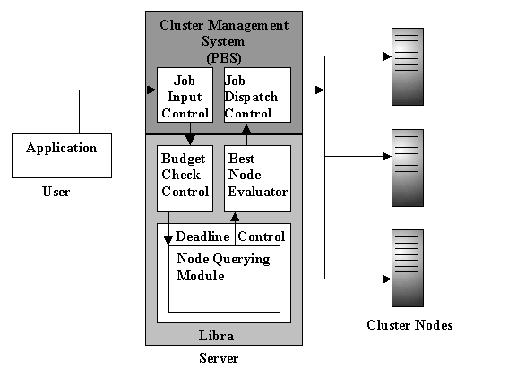

CHAPTER 6

IMPLEMENTATION

6.1 Scheduling Environment: PBS
As mentioned earlier, PBS provides a flexible mechanism for scheduling bath jobs in a networked environment. It provides a separate process to schedule which jobs should be placed into execution. The scheduling policy may be the pre-defined ones provided with PBS, or may be developed by the user.

The most extensive and useful scheduler provided with PBS is "fifo", which despite its name, implements numerous policies and scheduling algorithms such as round-robin, dedicated time, and shortest job first, each of which can be tailored to a the specific needs of a cluster. For our purposes, we adapted and extended the default fifo scheduler to provide for the user-driven needs of our cluster. This meant that we changed the policy and scheduling criteria, while still preserving useful functions such as those that initiated the scheduling cycle.

6.1.1 PBS components
The main components of PBS are:
- Job server, or pbs_server, which is the main server running servicing the user requests and running the central scheduler,
- PBS scheduler, or pbs_sched, which is the central scheduler that implements the scheduling policy and decided which job is to be run, when and where, and
- PBS execution host, or pbs_mom, which is the daemon that is run on execution nodes which, as the name suggests, execute user scripts and ensure that jobs do not overstep the allocated resources.

The life-cycle of a PBS job through these components looks like this:

- A user runs qsub to submit a job script to PBS. The user specifies the job execution time, the user budget, and the job deadline, either on the qsub command line or as directives within the job script file.
- The PBS server adds the job to a queue.
- The PBS server sends a message to the PBS scheduler asking it to evaluate the queue. It does this everytime a job is submitted, every time a job completes, and whenever a certain interval of time elapses (defined as the scheduler_iteration attribute of the server). It will also initiate a scheduling cycle whenever an administrator enters the qmgr command set server scheduling=true.
- The scheduler requests all the queue information from the server, and requests the server's attribute values as well. The server's attributes provide information such as how many compute nodes are available to PBS, how many have been allocated, the maximum number of jobs any user can have running at one time, and so on.
- If possible, the scheduler chooses jobs to run. It also chooses the service node on which each job should run. It does this by contacting the MOM on each node and requesting the system load of the service node. The scheduler assigns the PBS job to the least loaded service node.
- The scheduler sends the server a message telling it which jobs to run and what service nodes to run them on.
- For each job the scheduler wishes to place into execution, the server contacts the MOM on the service node and tells it to run the job.
- The MOM process starts the PBS job. It redirects the job's stdout and stderr streams to files in /tmp/pbs/working/spool.
- The MOM monitors the job for termination. When it terminates, the MOM copies the stdout and stderr files to the directory from which the user submitted the job. Then the MOM sends an obituary to the server.
- If the PBS job does not terminate within it's allotted time, the MOM sends a SIGTERM to it's parallel applications. After awhile it sends the parallel applications a SIGKILL and then kills the job script. Then it copies over the stdout and stderr streams, and sends an obituary to the server.

6.1.2 Scheduler-Server Interaction
In developing a scheduling policy, it was important for us to understand when and how the server and the scheduler interact. The server always initiates the scheduling cycle. The server opens a connection to the scheduler and sends a command indicating the reason for the scheduling cycle, which may be any of the following:

- A job newly becomes eligible to execute. The job may a new job in an execution queue, or a job in an execution queue that just changed state from held or waiting to queued. [ SCH_SCHEDULE_NEW ]
- An executing job terminates. [ SCH_SCHEDULE_TERM ]
- The time interval since the prior cycle specified by the server attribute is reached. [ SCH_SCHEDULE_TIME ]
- The server attribute is set or reset to true. If set true, even if it's value was true, the scheduler will be cycled. This provides the administrator/operator a means on forcing a scheduling cycle. [ SCH_SCHEDULE_CMD ]
- If the scheduler was cycled and it requested one and only one job to be run, then the scheduler will be recycled by the server. This event is a bit abstruse. It exists to "simplify" a scheduler. The scheduler only need worry about choosing the one best job per cycle. If other jobs can also be run, it will get another chance to pick the next job. Should a scheduler run none or more than one job in a cycle it is clear that it need not be recalled until conditions change and one of the above trigger the next cycle. [ SCH_SCHEDULE_RECYC ]
- If the server recently recovered, the first scheduling cycle, resulting from any of the above, will be indicated uniquely. [ SCH_SCHEDULE_FIRST ]

Once the server has contacted the scheduler and sent the reason for the contact, the scheduler then becomes a privileged client of the server. As such, it may command the server to perform any action allowed to a manager. The figure below indicates the simplified representation of a typical server-scheduler interaction cycle.

Figure 2: Scheduler Server Interaction in a Single-Host Environment

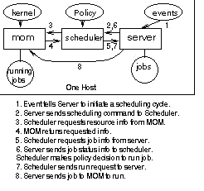

Libra with PBS
The lack of extensive literature on PBS’s inner workings made immediately delving into actual implementation difficult. PBS’s code is well-maintained and commented, however, an understanding of the “big picture” of how things worked across different modules was difficult to grasp from such comments. It was through many mails to the ever-useful PBS mailing list that we found answers to many of our (often simple) questions, and we are indebted to the people who helped us out.

Initially, to allow the submission of E, D and B (earlier defined as estimate, budget and deadline associated with a job) as input parameters with the job, we edited the src/include/site_job_attr_def.ht and src/include/site_job_attr_enum.ht files. Into these, we added descriptions of the three new variables, along the lines described in these files’ comments. After this, the qsub command began to accept values for E, D and B at the command line, using the -W option.

At this point, although the user could send these variables along with the job submitted to the server, the scheduler module was still running on its old considerations. The default PBS scheduler (called fifo, although it is much more than a simple fifo) works like this: it is summoned primarily every time a job is submitted, or completed. It begins by creating data structures which describe the entire cluster at that time; then, it queries the server for information to populate these data structures (most importantly server_info, node_info, job_info). Thus, we changed the data structure definitions to include E, D and B as part of job_info struct, and then also made the scheduler populate the updated structure with the values of these variables from the server.

The first thing to be done when checking for the viability of a job request was the budget, which we added to the schedule function as the first action after it begins considering the job to run. Based on a cost function [req_budget(B,E,D)], the budget is either rejected or accepted. If rejected, the user is told to increase his budget value to a higher amount or reduce his deadline. If accepted, the scheduler begins the next part of the scheduling process.

The actual task of ascertaining best_node for a job is now done, via the accept_reject_all_nodes function. This queries each cluster node (accessible through the nodes pointer) to see whether it can handle the new job’s (jinfo) constraints based on its present constraints or not. Each node calculates the minimum required share of CPU demanded by each job assigned to the node. Each job requires a minimum CPU share of:

jinfo->estimate - getCput(jinfo)__
jinfo->deadline - getWalltime(jinfo)

[jinfo->estimate is the estimate submitted by the user,
jinfo->deadline is the deadline submitted by the user,
getCput(jinfo) returns the CPU time currently executed by the job,
getWalltime(jinfo) returns the walltime currently taken by the job]

For example, if a job has run 20 out of the 30 CPU seconds it required, and has done so in 20 seconds, with a user-given deadline of 50 seconds, it needs a minimum quantum of (30-20)/(50-20) = 33.33% of the CPU for it to complete exactly within the remaining deadline. Thus, the minimum share value for each job is calculated, as well as the minimum share for the new job that is being considered, and all the values aggregated. This value is subtracted from 1.0 and sent to the server, as loadfree, the idle CPU share that will remain if this job is accepted by the node. The server checks to see if there is at least one node with a non-negative value for loadfree. If there is no such node, the job is rejected, and the user appropriately informed. Otherwise, the best_node is set to the node with the least value of loadfree, and PBS dispatches the job off to this node as normal.

Once at the node, the pbs_mom module, which is responsible for executing jobs on the nodes, dispatches the job to the kernel to actually execute. At this point in time, we have only tested the algorithm on a linux kernel which does not provide a method of ensuring CPU shares to jobs (e.g. via stride scheduling or lottery scheduling). Thus, we were not able to implement the CPU shares which were calculated previously. Instead, we modified the scheduler to assume that only integral divisions of CPU were allowed (i.e. 100%, 50%, 33%, 25%, and so on), which could be approximated by the default linux kernel.

CHAPTER 7

USER INTERFACE

User Characteristics
There are essentially two classes of users for the Libra Scheduler used with the Sun Grid Engine cluster management system: the user who wishes to submit jobs for the cluster and the administrator who oversees scheduling and cluster usage. The user needs to know the exact nature of the submitted job, such as the execution time as well as resources required, and must possess the technical know-how to use the interface for submitting jobs. The administrator must be an advanced cluster operator, fully qualified in using Linux, SGE, and the Libra Scheduler.

Libra with PBS-Web
For making our cluster more user-friendly and accessible, we designed an efficient front-end for the PBS-Libra engine using PBSWeb, an interface add-on to PBS developed at the University of Alberta. The PBSWeb interface was modified to suit the user-centric approach of Libra, included the provision for providing job budget, estimate and deadline with the job.

Figure 4: User-Server Interaction through the PBS-Libra Engine
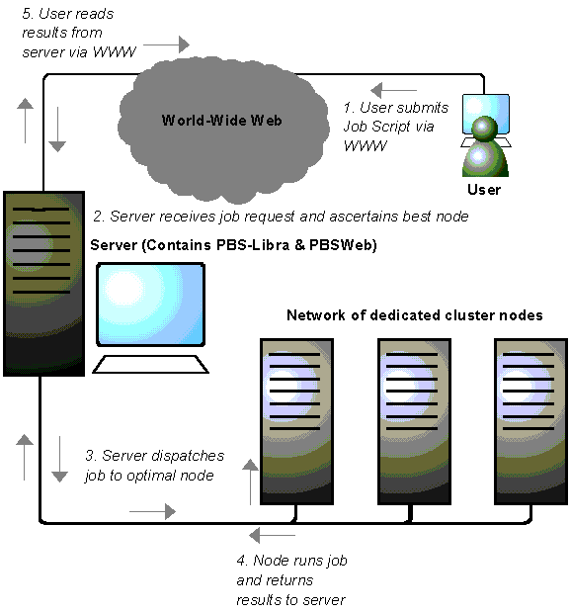
The general sequence of events in running a job through PBSWeb is essentially the same as in a command-line interface: user login, job file upload, job script generation, queue status check if necessary, job status check, and job output. PBSWeb makes it easy for even novice users to use our cluster for running their jobs. Either interface can be used, depending on the user preference. To demonstrate an example, the command-line interface for the job submission command would be:

qsub filename.pbs –w deadline=x, budget=y, estimate=z

where the job defined by filename.pbs has been uploaded in the source directory.

PBSWeb would similarly involve the uploading of the job through the website, the specification of the job details in textboxes, and the subsequent submission of the job to the cluster through the “Submit” command. The self-descriptive snapshots of the user interface of the PBS-Libra engine are provided below, to highlight the simple and convenient use of the front-end of the PBS-Libra Engine.

Figure 1: The Start Page for the PBS-Libra Engine

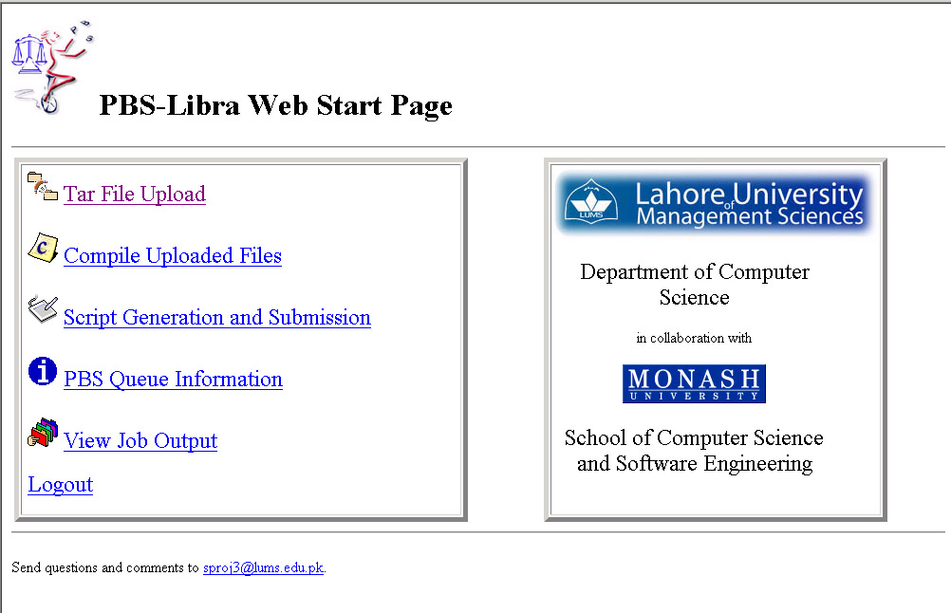

Figure 2: The Login Page for the PBS-Libra Engine



Figure 3: The Job Selection Page for the PBS-Libra Engine

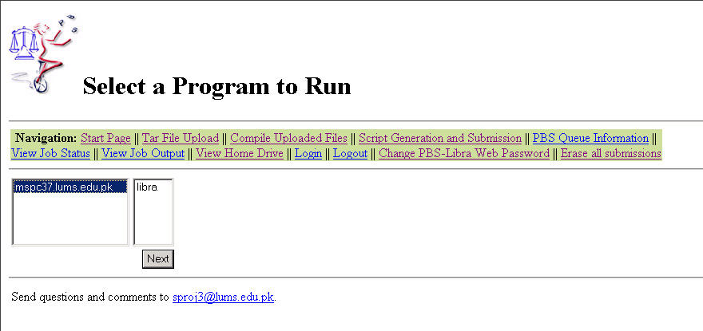

Figure 4: The Script Submission Page for the PBS-Libra Engine

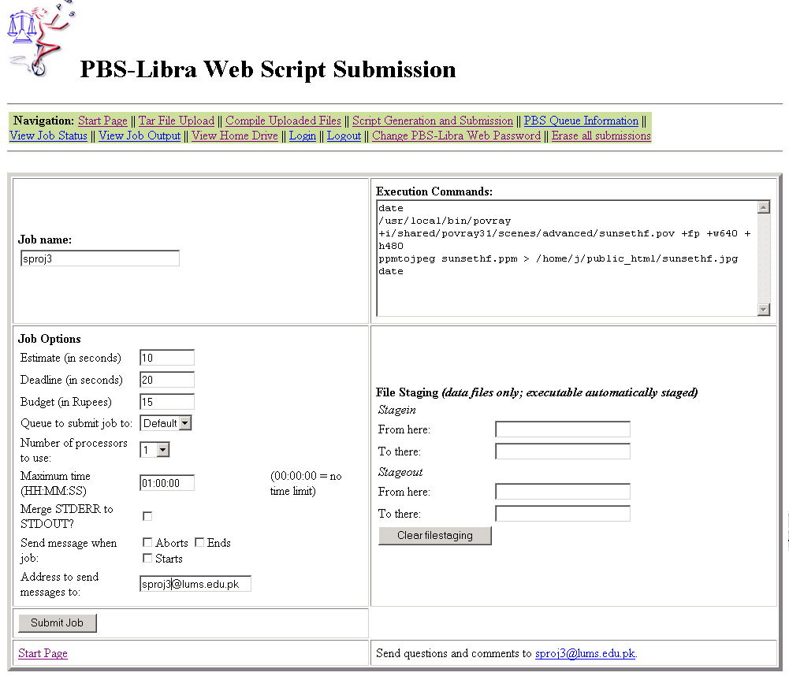

Figure 5: The Script Submission Results Page for the PBS-Libra Engine

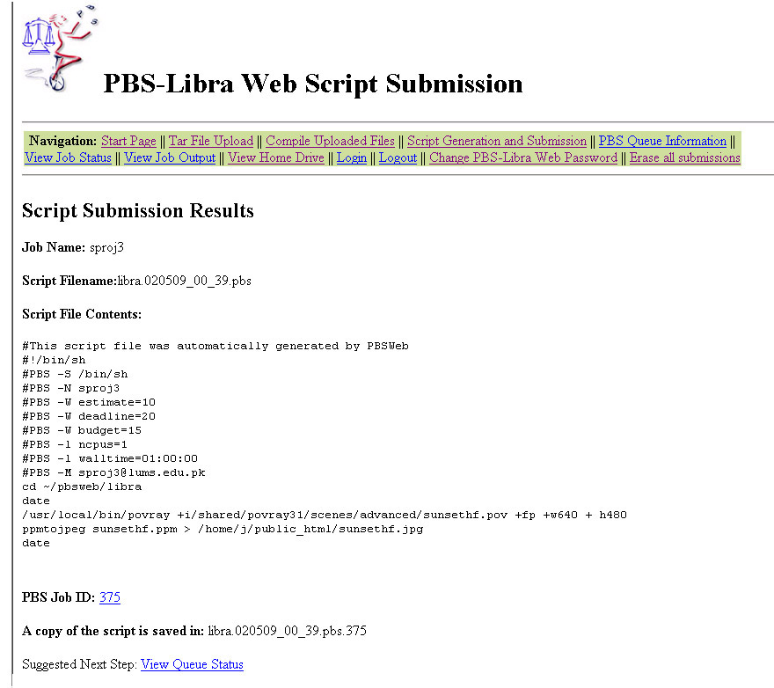

Figure 6: Viewing the Job Status through PBS-Web

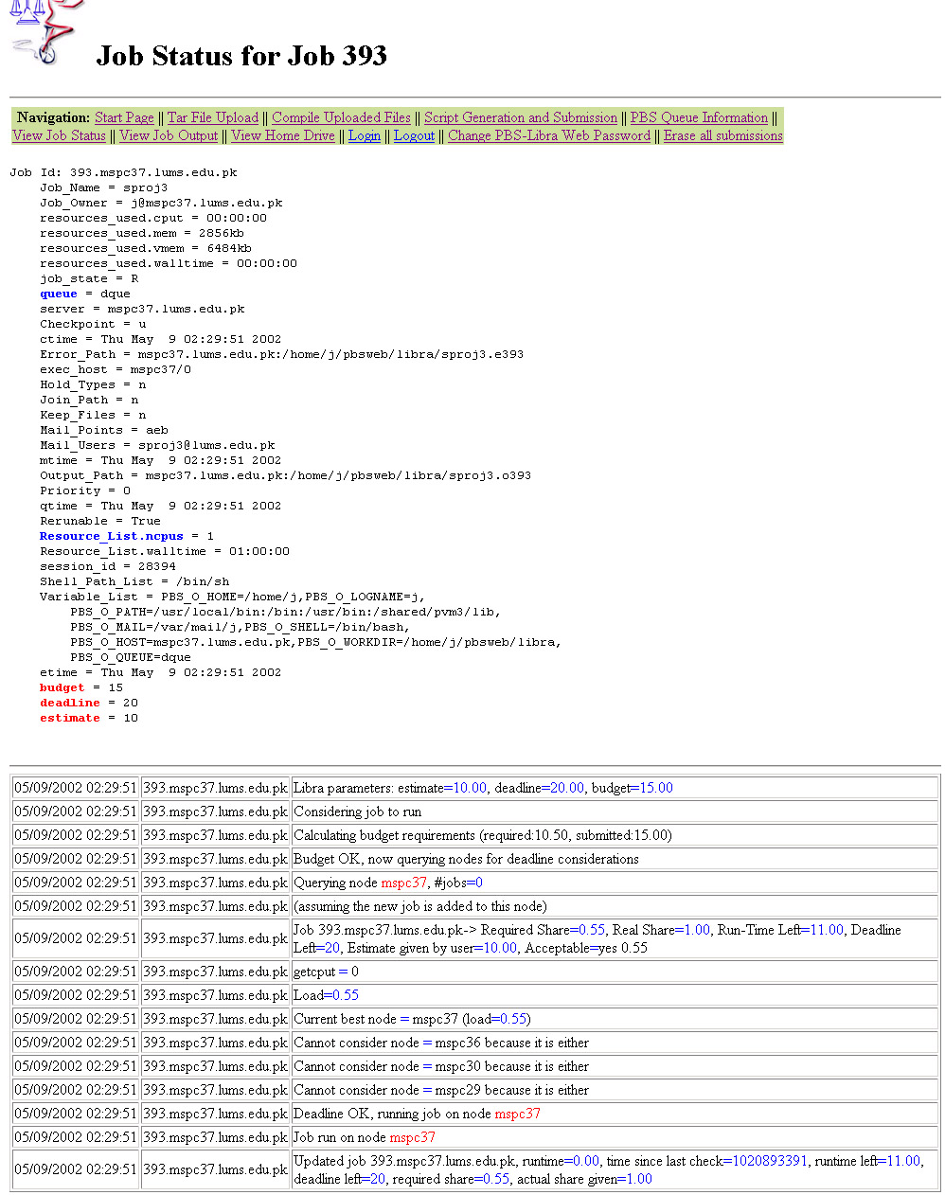… ...continued on the next page

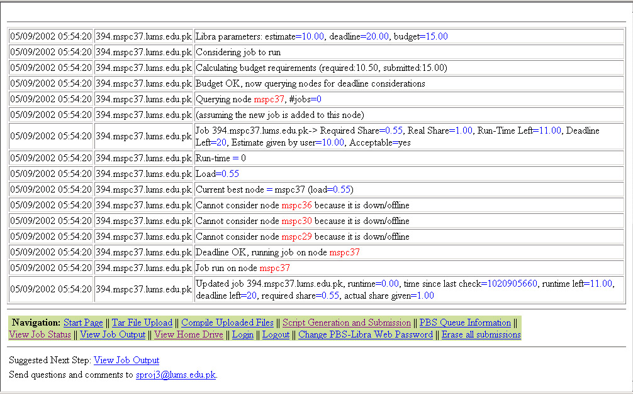

Figure 7: Viewing the Job Output and Error Files through PBS-Web

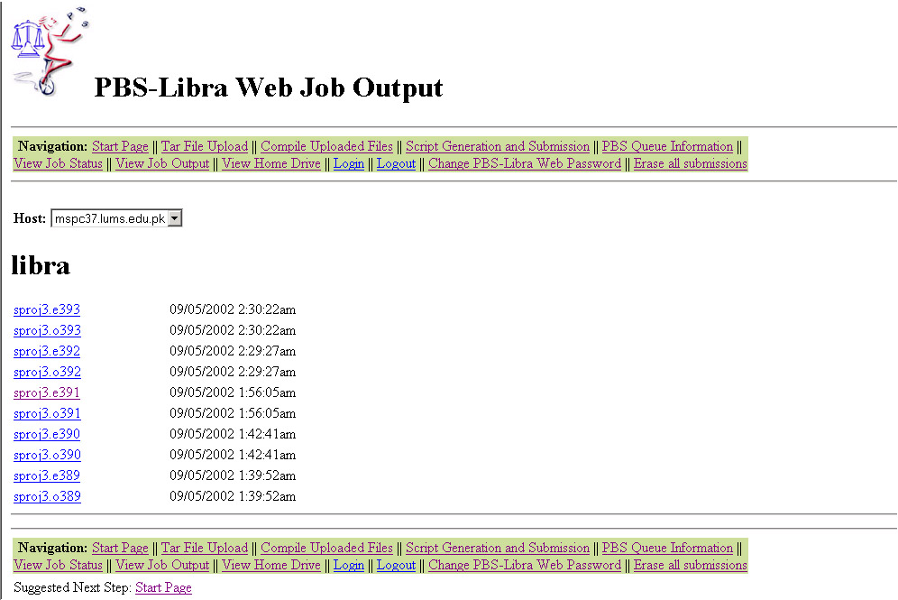

For example, “Nimrod/G: An Architecture for a Resource Management and Scheduling System in a Global Computational Grid”, by Rajkumar Buyya, David Abramson, and Jonathan Giddy, 2000.
James, Heath A. Scheduling in Metacomputing Systems,
Adapted from http://www.cs.sandia.gov/cplant/doc/runtimeAdmin1_0/node68.html
http://www.openpbs.com/UserArea/docs-AG/AG-46.html
http://www.openpbs.org/scheduler.html

