Libra: An Economy-Driven Cluster Scheduler
Design Documentation

Version <1.0>
Revision History
Date | Version | Description | People
<28/Jan/02> | <1.0> | First draft | Project Owner and Client: Rajkumar Buyya  Faculty Advisor: Dr. Arif Zaman  Project Group: Jahanzeb Sherwani, Nosheen Ali, Nausheen Lotia, Zahra Hayat

Table of Contents
1. Introduction 4
2. Design 5
3. Architecture 6
4. Interfaces 7
4.1 QMonitor 7
4.2 QMonitor – Job Control (Pending Jobs) 8
4.3 QMonitor – Job Control (Finished Jobs) 9
4.4 Submit Job 10
4.5 Queue Control 11
4.6 Queue Configuration: Modify 12
4.7 Host Configuration (Administration Host) 13
4.8 Complex Configuration 14
4.9 Cluster Configuration 15
4.10 Scheduler Configuration 16
5. Data Definitions 17
6. Architectural and Procedural Design 22
6.1 Job Input Controller 24
6.2 Job Acceptance Controller 25
6.3 Job Initialization Controller 26
6.4 Job Assignment Controller 27
6.5 Execution Host and Queue Determination Controller 28
6.6 Job Execution Controller 29
6.7 Job Query Controller 30
6.8 Job Modification Controller 31
7. Program Design Language (Low-Level Design) 32
7.1 Log User In and Input Job 32
7.2 Accept / Reject Job 33
7.3 Compute Job finish Time 34
7.4 Determine Execution Host and Queue 34
7.5 Schedule according to deadline and budget 35
7.6 Implement proportional scheduling model according to allocated tickets 36
7.7 Select Job (according to stride scheduling algorithm) 38
7.8 Query Job 39
7.9 Delete Job 40
7.10 Change Job Details 41
8. References 42

Design Documentation

Introduction

This document contains the high-level and low-level design specifications for the Software Requirements Specifications (SRS) submitted on 23rd December 2001. Additionally, the software architecture, and user interfaces for each of the deliverables are described as well.

Design

For the high-level design, a call-return architecture has been specified using structure charts. For procedural design, the high-level design modules have been explained using PDL.

Architecture

The Libra Scheduler architecture is as follows:
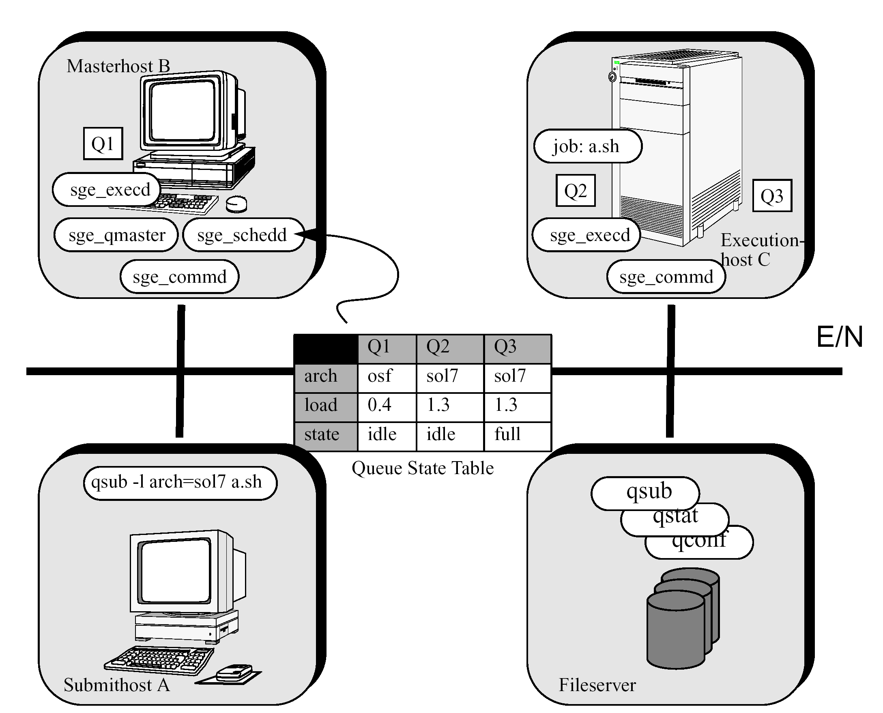
The fileserver stores the workspaces of all processes, as well as the binary executables of the scheduler itself. Communications daemons (commd) are running on each of the host on a specified TCP port (786), and form the means of communication between hosts. Execution hosts contain execution queues, each with their own scheduling policies, on which jobs are sent to execute. The master host contains the central queue managing daemon, qmaster, and the scheduling daemon, which makes the actual scheduling decisions regarding which job is to be assigned to which execution queue. Submit hosts are the entry-points for the users. A submit host submits jobs using the ‘qsub’ command, which submits the job along with its corresponding details to the master host. The master host summons the scheduler, which has access to the Queue State Table which in turn contains information on each of the execution hosts. Based on the scheduling algorithm implemented via Libra, the scheduler will choose an execution queue, which the qmaster will subsequently dispatch the job to.

Interfaces

QMonitor


This is the central control screen for the Sun Grid Engine within which the Libra Scheduler is to be implemented. From here, the options (from top left to bottom right) are:
- Job Control
- Queue Control
- Job Submission
- Complexes Configuration
- Host Configuration
- Cluster Scheduler
- Scheduler Configuration
- Calendar Configuration
- User Configuration
- Parallel Environment Configuration
- Checkpoint Configuration
- Browser
- Exit

QMonitor – Job Control (Pending Jobs)

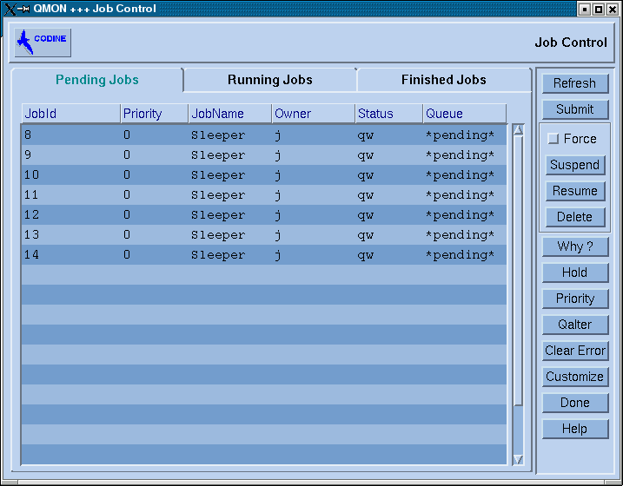
Once a job is submitted, it goes to the master host which places it in the pending jobs queue. Once there, its ID, Priority, Name, Owner, Status and Queue (to which it will be sent) are stored until the job is actually dispatched to the queue. Every job initially goes to the pending queue while the scheduling daemon runs the selected scheduling algorithm to determine the execution queue to which the job is to proceed. Once this is done, the job goes into the Running Jobs tab (not shown in the screen images), after which it ends up in the finished jobs queue.

QMonitor – Job Control (Finished Jobs)

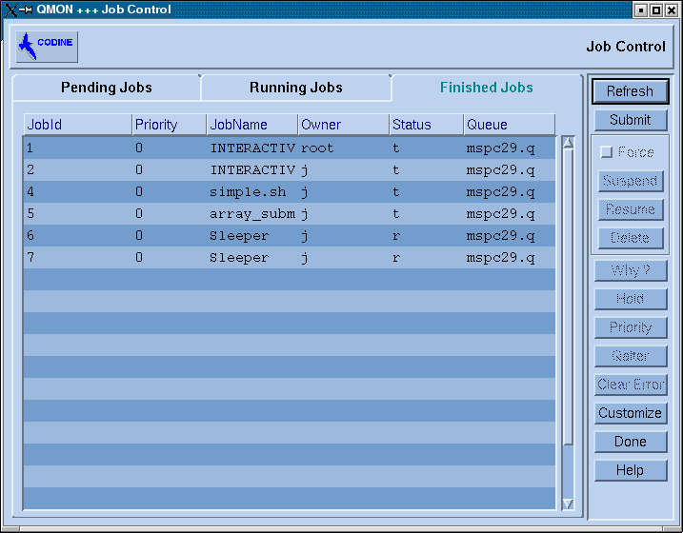
The jobs in the finished jobs queue are those that have been scheduled, executed, and completed. It is essentially a list of all the hitherto completed jobs that have been submitted and outputs returned.

While job status may be viewed from the Job Control window, new jobs may be submitted by clicking on the Submit button, which opens up the Job Submit dialog window.

Submit Job

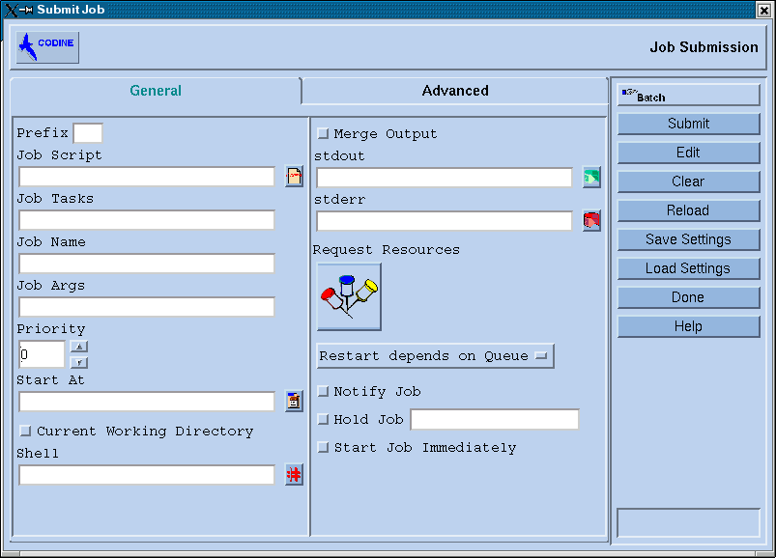
Jobs are submitted using this dialog window. The job script specifies the location of the file containing the actual executable commands (for example, “sleeper.sh”). Job args takes in the arguments for the job, including deadline, budget, and expected exeuction time. Output may be directed to different files, and is specified in the stdout and stderr input boxes. Only those hosts that are specified submit hosts on the master host have privileges to submit jobs, however.

Queue Control

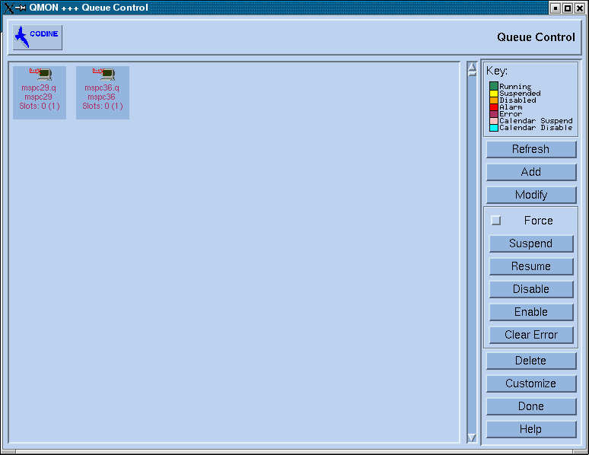
This window lists the currently configured queues for the execution hosts in the cluster. In the above example, execution hosts mspc29 and mspc36 each have a queue (called ‘q’) running on each of them, and each of these queues has 0 out of a maximum of 1 job running on them. Further, more queues may be added to the specified execution hosts, and existing queues may be modified or deleted.

Queue Configuration: Modify
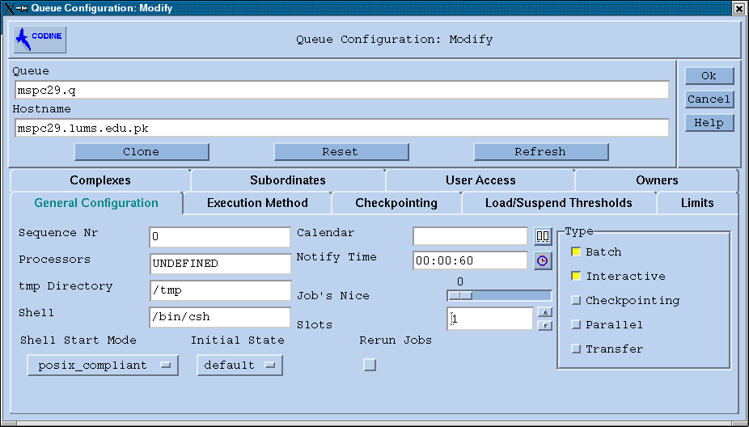
This is the window from which queue configurations may be changed. For instance, different load/suspend thresholds, which specify the ceiling of maximum allowed load for the queue, beyond which it will begin to suspend jobs running on it till the threshold is satisfied. Also, complexes may be attached or detached from the queue, making queues cater to different resource requirements (in our case, deadline and budget). Checkpointing (the process of saving the current status of any job, for later restarting, or for job migration) can also be configured for each queue individually, to set the conditions under which checkpointing and/or job migration occur. User access specifies which users/hosts are to be given access, and which are to be denied. Subordinates includes those queues that are to follow suit with whatever instructions are sent to this queue; for instance, if a queue is suspended, then its subordinates will be suspended as well. Limits specifies the hard or soft limits imposed on jobs running on the queue (for example, no job may take more than 10 minutes of CPU time, otherwise it is to be suspended or killed).

Host Configuration (Administration Host)

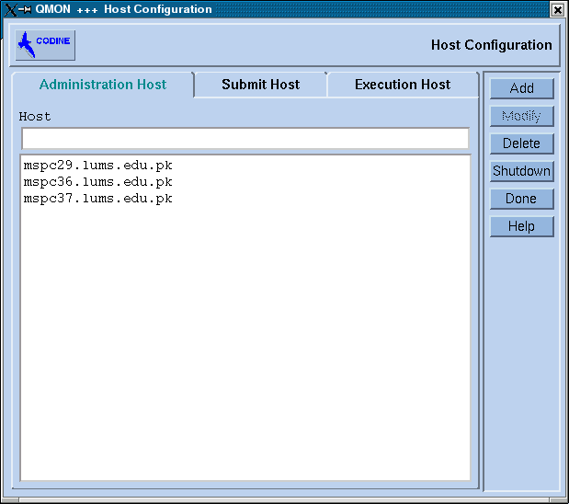
In this window, hosts are configured. The three type of hosts recognized are Administration, Submit, and Execution hosts. Administration hosts are those hosts that are allowed to view and edit the configuration for the cluster as a whole, for hosts individually, for queues within specific hosts, as well as for jobs running on specific queues. Submit hosts are those that are allowed to submit jobs into the cluster. Execution hosts are those that have at least one queue set up where jobs scheduled by the cluster may be sent to actually execute.

Complex Configuration

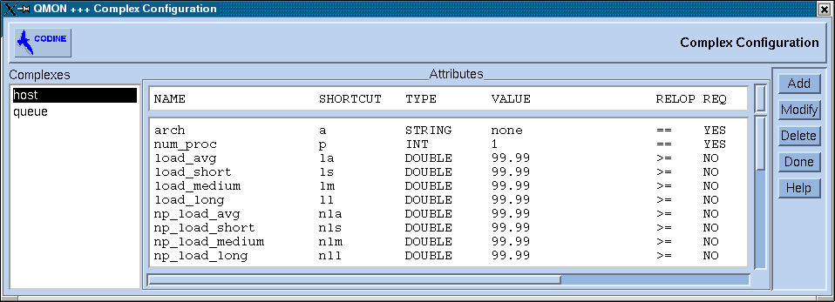
Complexes are entities representing some aspect of the cluster that the cluster administrator defines. For instance, CPU usage, Virtual Memory usage, Disk Storage usage, are all complexes that the administrator can define and then attach onto specific queues or hosts (as shown in the queue configuration modification screenshot). By attaching a complex to a queue, and defining an associated limit for that complex, the administrator can effectively define a policy for the queue. For instance, one queue may be configured such that no process that requires more than 10 Mb of disk space may be run. Alternatively, another queue may be defined such that the total amount of memory used by processes does not exceed the physical RAM on the host, such that no virtual memory is used, thus speeding execution times. In our case, a complex defining user budget, and another defining user deadline can both be used concurrently to define the behavior for a queue that can effectively ensure that user deadlines and budgets are accounted for during queue execution. This can act as a sentinel in case the scheduling algorithm inaccurately calculates the scheduling policy for the cluster.

Cluster Configuration

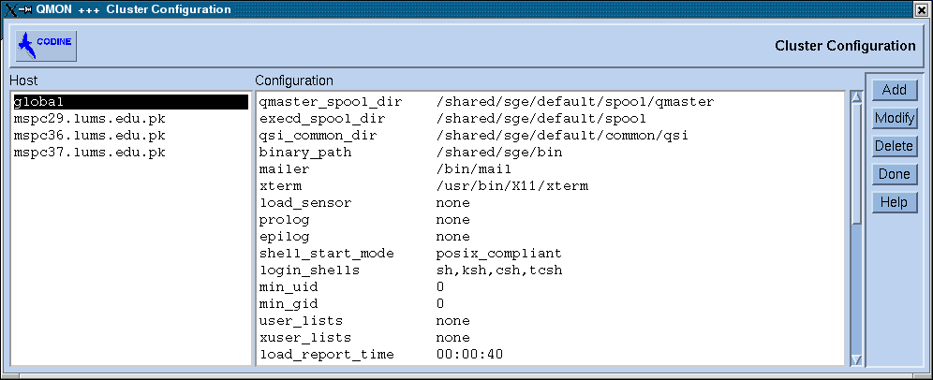
This window allows the administrator to define the local policies for hosts in the cluster as well as the global policies for the entire cluster as a whole. Global policies are defined which are inherited by hosts, and in turn inherited by queues in those hosts. Alternatively, hosts may define their individual policies that override the global policies as required. Finally, policies may also be defined for individual queues that override both the global as well as host-level policies. Thus, there is a great degree of customizability for the specific needs of the cluster.

Scheduler Configuration

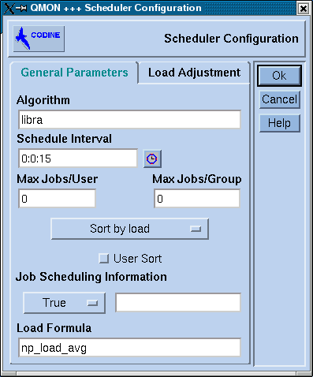
This is the window from which the scheduling algorithm (as described by the high-level design diagrams) is selected for the master host’s scheduling daemon. This is effectively the master scheduling policy for the cluster, which selects the hosts and queues that are to be allocated to each job. This algorithm effectively schedules jobs based on the user constraints of deadline and budget, within which it maximizes as much as possible system-centric constraints such as CPU utilization, etc.

Data Definitions

Name: Cluster Information stored in Cluster State Table
Aliases: Updated Cluster Information
Where used/how used: Schedule Job (input)
Accept/Reject Job (input)
Content Description: Cluster Information = CPU Load + Node Status + Remaining Time of Pending Jobs + Available Memory

CPU Load = numeric

Node Status = [full | overloaded | partially-full]

full = string

overloaded = string

partially-full = string

Remaining Time of Pending Jobs = (hours) + (minutes) + (seconds)
Hours = double
Minutes = double
Seconds = double

Available Memory = numeric

Supplementary Information: This is the information maintained by the master host. It is collected periodically from all the execution hosts and also communicated to the scheduler to enable it to make its scheduling decisions.

Name: Job Details
Aliases: Job Parameters, Job Specifications
Where used/how used: Get Job Details (output)
Schedule Job (output)
Accept/Reject Job (input)
Determine Execution Host (input)
Implement Scheduling Policy (input)
Content Description: Job Details = Job ID + Job Name + Job Type + Standalone Execution Time + Location of Executable and Input Data Sets + Location of Output + System Type + Budget + Deadline
Job ID = integer
Job Name = string
Job Type = [Sequential Job | Embarrassingly Parallel Job]
Sequential Job = char
Embarrassingly Parallel Job = char
Job Category = [Deadline | Budget | Deadline and Budget]
This explains what is provided as the criterion for job
Job Start Time = integer
Job Submit Time = integer
Standalone Execution Time = Job Duration
Job Duration = (hours) + (minutes) + (seconds)
Hours = double
Minutes = double
Seconds = double
Location of Execution and Input Data Sets = string
Location of Output = string
System Type = string

Budget = rupees
Rupees = double
Deadline = (hours) + (minutes) + (seconds)
Hours = double
Minutes = double
Seconds = double
Supplementary Information: none

Name: Scheduling Information
Aliases: Scheduling Policy Implementation
Where used/how used: Schedule Job (output)
Execute Job (input)
Implement Scheduling Policy (output)
Content Description: Scheduling Information = Tickets + Stride + Pass

Tickets = integer

Stride = integer

Pass = integer

Supplementary Information: Tickets represent the client’s resource allocation, relative to other clients.
Stride represents the interval between selection for execution, measured in passes, and is the inverse of tickets.
Pass represents the virtual time index for the client’s next selection.

Name: Job Results
Aliases: Job Output
Where used/how used: Execute Job (output)
Content Description: Job Results = (string) + (char) + (numeric)
Supplementary Information: These are the results of the execution of the job, and are communicated to the user on the submit host from the execution host via the master host.

Name: Required Budget/Deadline
Aliases: none
Where used/how used: Accept/Reject Job (output)
Content Description: Required Budget/Deadline = Deadline + Budget
Budget = rupees
Rupees = double
Deadline = (hours) + (minutes) + (seconds)
Hours = double
Minutes = double
Seconds = double
Supplementary Information: This data object represents the response of the system to the submission of a job that cannot be completed with the requested parameters. The system then notifies the user, and demands a different budget and/or deadline.

Name: Chosen Execution Host
Aliases: Chosen Execution Node
Where used/how used: Determine Execution Host (output)
Dispatch Job to Execution Host (input)
Dispatch Job to Execution Host (output)
Update Cluster Status (input)
Content Description: Chosen Execution Host = (Host Name) + Host IP Address

Host Name = string

Host IP Address = numeric

Supplementary Information: This is decided by the scheduler, based on the Cluster Information
available to it.

Name: Chosen Execution Queue
Aliases: none
Where used/how used: Determine Execution Host (output)
Dispatch Job to Execution Host (input)
Dispatch Job to Execution Host (output)
Update Cluster Status (input)
Content Description: Chosen Execution Queue = (Queue Name) + Queue Number

Queue Name = string

Queue Number = numeric

Supplementary Information: This is decided by the scheduler, based on the Cluster Information
available to it.

Name: Scheduled Job
Aliases: Dispatched Job
Where used/how used: Schedule Job (output)
Execute Job: Stride Scheduling (input)
Dispatch Job to Execution Host (output)
Content Description: Scheduled Job = Job Details + Chosen Execution Host + Chosen Execution Queue
Job Details = Job ID + Job Name + Job Type + Standalone Execution Time + Location of Executable and Input Data Sets + Location of Output + System Type + Budget + Deadline
Job ID = integer
Job Name = string
Job Type = [Sequential Job | Embarrassingly Parallel Job]
Sequential Job = char
Embarrassingly Parallel Job = char
Standalone Execution Time = Job Duration
Job Duration = (hours) + (minutes) + (seconds)
Hours = double
Minutes = double
Seconds = double
Location of Execution and Input Data Sets = string
Location of Output = string
System Type = string
Budget = rupees
Rupees = double
Deadline = (hours) + (minutes) + (seconds)
Hours = double
Minutes = double
Seconds = double

Chosen Execution Host = (Host Name) + Host IP Address

Host Name = string

Host IP Address = numeric

Chosen Execution Queue = (Queue Name) + Queue Number

Queue Name = string

Queue Number = numeric

Supplementary Information: This data object represents a job once it has been accepted by the
system, and its execution node and execution queue.

Architectural and Procedural Design

Job Input Controller

Job Acceptance Controller

Job Initialization Controller

Job Assignment Controller

Execution Host and Queue Determination Controller

Job Execution Controller

Job Query Controller

Job Modification Controller

Program Design Language (Low-Level Design)

Log User In and Input Job

Output: userID

UserID = getUserIdFromUser
Password = getPasswordFromUser
If UserID and Password match UserID and Password in database
Send authentication signal
Request Job details
Verify Job Details
Assign Job Id and Initialize Job
Else
Display error and ask for UserID and Password again
Return userID

Accept / Reject Job

Input: jobDetails
Output: jobAcceptedSignal

qLoadList = clusterStateTable.QueueList
clusRes = clusterResourceList

send clusterReady signal

c = jobDetails.category
t = jobDetails.type
e = jobDetails.execTime
b = jobDetails.budget
d = jobDetails.deadline

Loop through qLoadList
If current.rate <= b and current.type = t
finTime = call procedure computeJobFinishTime(current.load, e)
If fineTime <= deadline
Return accept job signal

Return deny job signal

Compute Job finish Time

Input: queueLoad, jobExecTime
Output: finishTime

Loop through the queueLoad timeSlots until jobExecTime is zero
If currentTimeSlot is free
jobExecTime = jobExecTime - size of currentTimeSlot
Return currentTimeSlot

Determine Execution Host and Queue

Input: jobDetails, ClusterInfo
Output: chosenExecQueue, chosenHost

HostLoadList = List of the Loads on each Host
Set initial load as minimum
Loop though list of loads
If current load < minimum so far
minimum = current number
chosenHost = HostLoadList(minimum)
queueList = QueueStateTable [HostLoadList(chosenHost)]

Set first queue as chosenExecQueue
Loop through the queuelist
If there exist slots in current queue that fulfill jobdetails.execTime
choose current queue as chosenExecQueue
ScheduledJobDetails.startTime = current time
Return (chosenExecQueue,chosenHost)

Schedule according to deadline and budget
Algorithm:
M - Resources, N - Jobs, D - deadline
Note: Cost of any Ri is less than any of Ri+1 Or Rm
RL: Resource List need to be maintained in increasing order of cost
Ct - Time when accessed (Time now)
Ti - Job runtime (average) on Resource i (Ri) [updated periodically]
Ti is acts as a load profiling parameter.
Ai - number of jobs assigned to Ri , where:
Ai = Min (No.of Unassigned Jobs, No. Jobs Ri can complete by remaining deadline)
No.UnAssignedJobsi = Diff( N, (A1+…+Ai-1))
JobsRi consume = RemainingTime (D- Ct) DIV Ti
ALG: Invoke Job Assignment() periodically until all jobs done.
Job Assignment():
Establish ( RL, Ct , Ti , Ai ) dynamically.
For all resources (I = 1 to M) { Assign Ai Jobs to Ri , if required }

Implement proportional scheduling model according to allocated tickets
We are using the stride scheduling algorithm to allocate quantums between jobs, to implement their priorities according to their budget and deadline. The tickets represent their priority and are determined according to prioritizing sorted lists of jobs according to budget and sorted lists according to deadline, and determining their combined priorities to figure out the eventual priorities of these jobs.
The Algorithm is as follows:
/* per-client state */
typedef struct {
…
int tickets, stride, pass, remain;
} *client t;

/* quantum in real time units (e.g. 1M cycles) */
const int quantum = (1 << 20);

/* large integer stride constant (e.g. 1M) */
const int stride1 = (1 << 20);

/* current resource owner */
client t current;

/* global aggregate tickets, stride, pass */
int global tickets, global stride, global pass;

/* update global pass based on elapsed real time */
void global pass update(void)
{
static int last update = 0;
int elapsed;

/* compute elapsed time, advance last update */
elapsed = time() - last update;
last update += elapsed;

/* advance global pass by quantum-adjusted stride */
global pass +=
(global stride * elapsed) / quantum;
}
/* update global tickets and stride to reflect change */
void global tickets update(int delta)
{
global tickets += delta;
global stride = stride1 / global tickets;
}

/* initialize client with specified allocation */
void client init(client t c, int tickets)
{
/* stride is inverse of tickets, whole stride remains */
c->tickets = tickets;
c->stride = stride1 / tickets;
c->remain = c->stride;
}

/* join competition for resource */
void client join(client t c, queue t q)
{
/* compute pass for next allocation */
global pass update();
c->pass = global_pass + c->remain;

/* add to queue */
global tickets update(c->tickets);
queue insert(q, c);
}

/* leave competition for resource */
void client leave(client t c, queue t q)
{
/* compute remainder of current stride */
global pass update();
c->remain = c->pass - global_pass;

/* remove from queue */
global tickets update(-c->tickets);
queue remove(q, c);
}

/* proportional-share resource allocation */
void allocate(queue t q)
{
int elapsed;
/* select client with minimum pass value */
current = queue remove min(q);

/* use resource, measuring elapsed real time */
elapsed = use resource(current);
/* compute next pass using quantum-adjusted stride */
current->pass +=
(current->stride * elapsed) / quantum;
queue insert(q, current);
}

Select Job (according to stride scheduling algorithm)

Output: selectedJob

currJobList = currentlyExecutingJobList
Set first job as minimum
Loop through currJobList
If currentJob.pass < minimum.pass
minimum = currentJob
selectedJob = currJobList(minimum)
Return selectedJob

Query Job
Output: Required queries displayed on screen

userID = getUserIdFromUser
password = GetPasswordFromUser
If UserID and Password match UserID and Password in database
Send authentication signal
Else display error and ask for UserID and Password again
jobID = getJobIDFromUser
If jobID and UserID tally
Send authentication signal
Else display error message and ask user for jobID again
Display job attirbutes that user may view
If remainingTime is selected
call procedure calculateRemainingTime(jobID)
If startTime is selected
display jobDetails.startTime
If budget is selected
display jobDetails.budget
If Deadline is selected
display jobDetails.deadline
If Execution Host and Queue is selected
display jobDetails.execHost and jobDetails.execQueue

Delete Job

Input: jobID
Output: updatedClusterStatus

eHost = jobDetails.execHost
eQueue = jobDetails.execQueue

eQueue.delete(jobID)
clusterStateTable.host(eHost).resources -= calculateRemainingTime(jobID)

Change Job Details

Input: jobID, choice

If choice = name
newName = readNewNameFromUser()
If newName is blank
Display error message and ask user to enter new name again
Else
jobDetails.name = newName

If choice = location of execution and input data sets
currJobList = currentlyExecutingJobList
Loop through currJobList
If currentJob.jobID = jobID
Display error message
Return
newLoc = readNewLocationFromUser()
jobDetails.inputLocation = newLoc

If choice = location of output
newLoc = readNewLocationFromUser()
jobDetails.outputLocation=newLoc

References

[1] R. Buyya, D. Abramson, and J. Giddy, Nimrod/G: An Architecture for a Resource Management and Scheduling System in a Global Computational Grid, HPC ASIA’2000, China, IEEE CS Press, USA, 2000.

[2] R. Buyya, D. Abramson, J. Giddy, An Economy Driven Resource Management Architecture for Global Computational Power Grids, The 2000 International Conference on Parallel and Distributed Processing Techniques and Applications (PDPTA 2000), Las Vegas, USA, June 26-29, 2000.

[3] R. Buyya, D. Abramson, and J. Giddy, An Economy Grid Architecture for Service-Oriented Grid Computing, 10th IEEE International Heterogeneous Computing Workshop (HCW 2001), with IPDPS 2001, SF, California, USA, April 2001.

[4] Rajkumar Buyya, Heinz Stockinger‡, Jonathan Giddy, and David Abramson, Economic Models for Management of Resources in Peer-to-Peer and Grid Computing, Monash University.

[5] B.N. Chun and D.E. Culler, Market-based proportional resource sharing for clusters. Submitted for publication, September 1999.

[6] Sun Microsystems, Inc., Sun Grid Engine 5.2.3 Manual. July 2001

