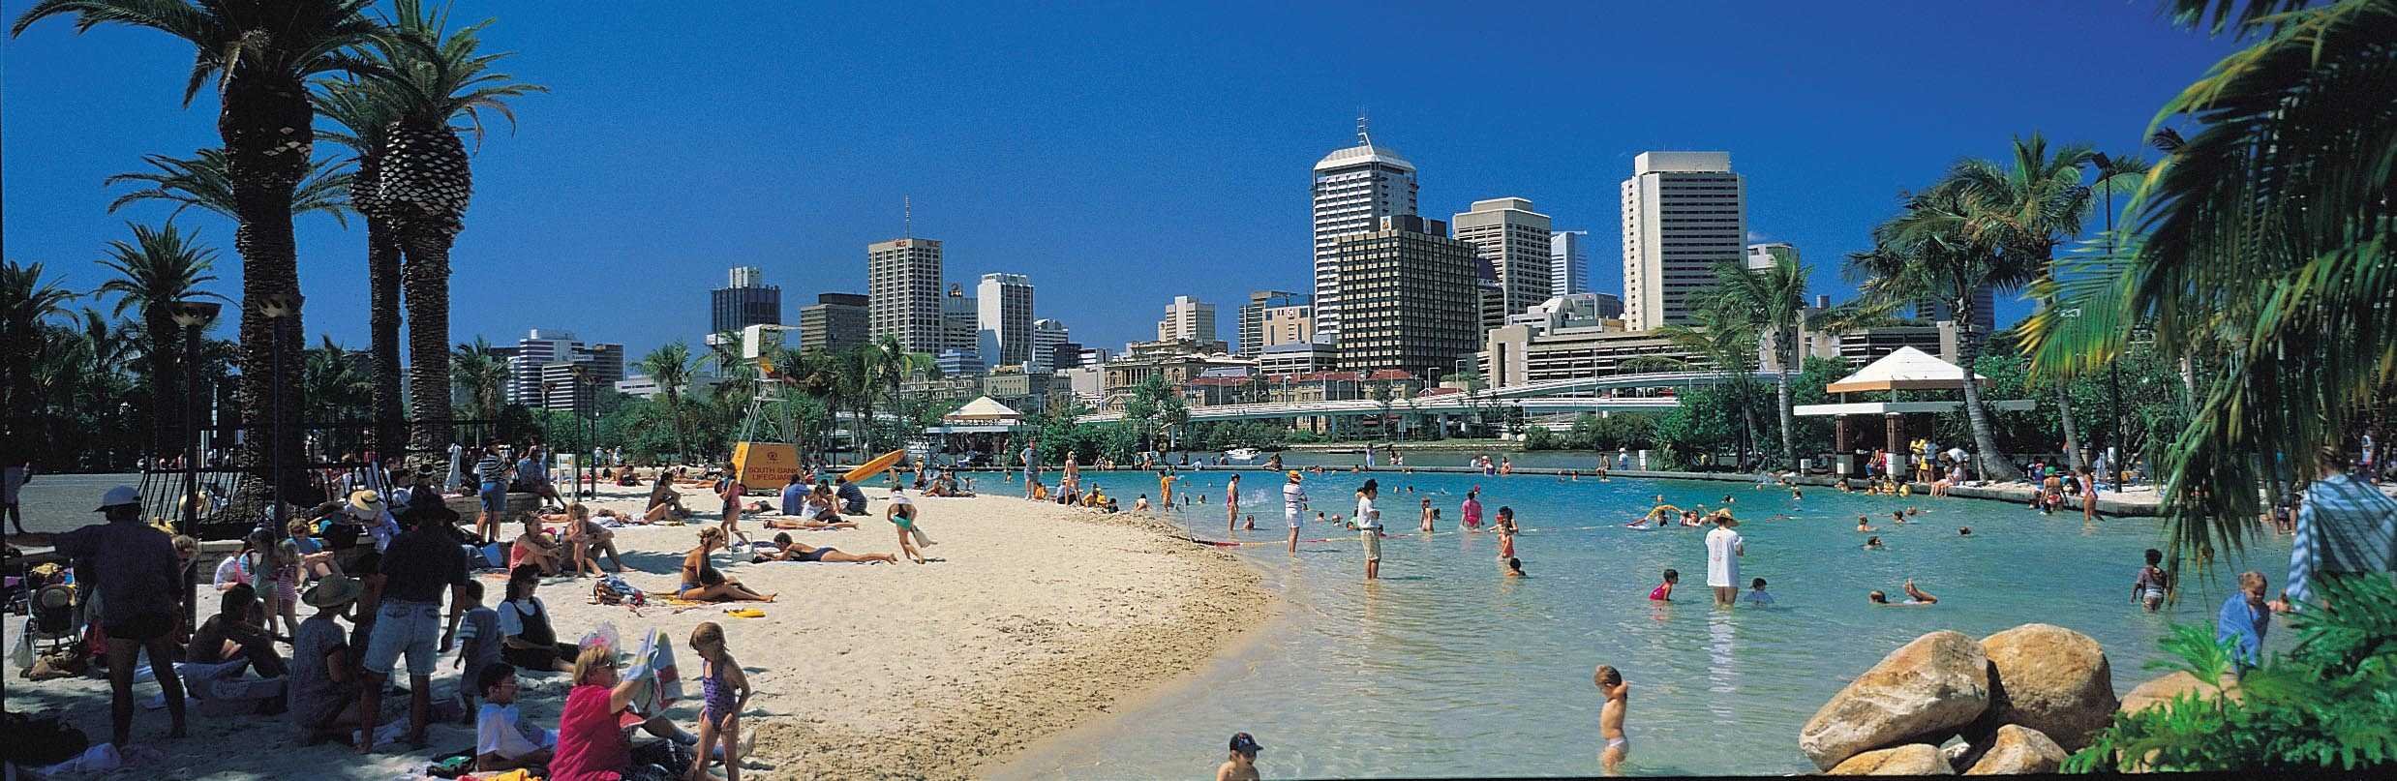


South Bank, Brisbane, Australia

Call for Participation
ACM/IEEE International Symposium on

Cluster Computing & the Grid

15-18 May 2001

Rydges Hotel South Bank Brisbane

Early bird  registration  (see web site) | 31 March
Tutorials & workshops | 15 May
Symposium main stream & workshops | 16-18 May

Enquiries to: Paul Roe
ccgrid2001@qut.edu.au

Keynotes

Ian Foster: The Anatomy of the Grid: Enabling Scalable Virtual Organizations

Andrzej Goscinski: Making Parallel Processing on Clusters Efficient, Transparent and Easy for Programmers

Domenico Laforenza: Programming High Performance Applications in Grid Environments

Bruce Maggs: Challenges in Scalable Content Distribution over the Internet

Satoshi Matsuoka: Grid RPC meets Data Grid: Network Enabled Services for Data Farming on the Grid

Greg Pfister: The Promise of InfiniBand for Cluster Computing

Tutorials

Ian Foster: The Globus Toolkit for Grid Computing
Tim Mattson: SMP Programming with OpenMP

Panel The Grid: Moving it to Prime Time

Industry talks Intel, MPISoft, Platform, Sun

Workshops

Agent based Cluster and Grid Computing
Cluster Computing Education
Distributed Shared Memory on Clusters
Global Computing on Personal Devices
Internet QoS for Global Computing
Object & Component Technologies for Cluster Computing
Scheduling and Load Balancing on Clusters

www.ccgrid2001.qut.edu.au

